**Name: ___________________ Class: ­­­­­­­­­­­­­­­ __________**

Exercise 1: Read and color:

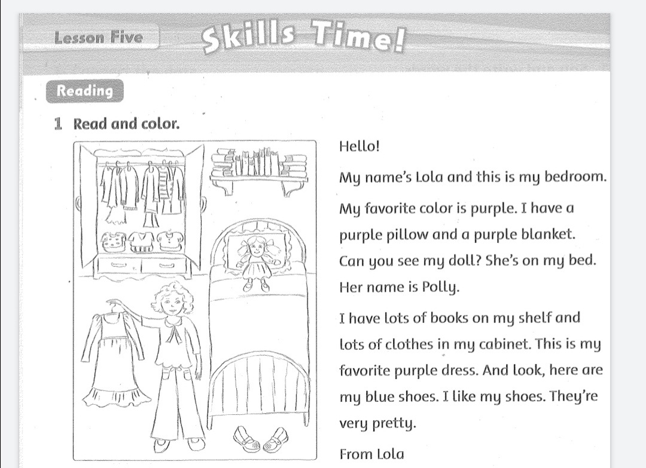

Exercise 2: Read again. Fill in the correct circle:

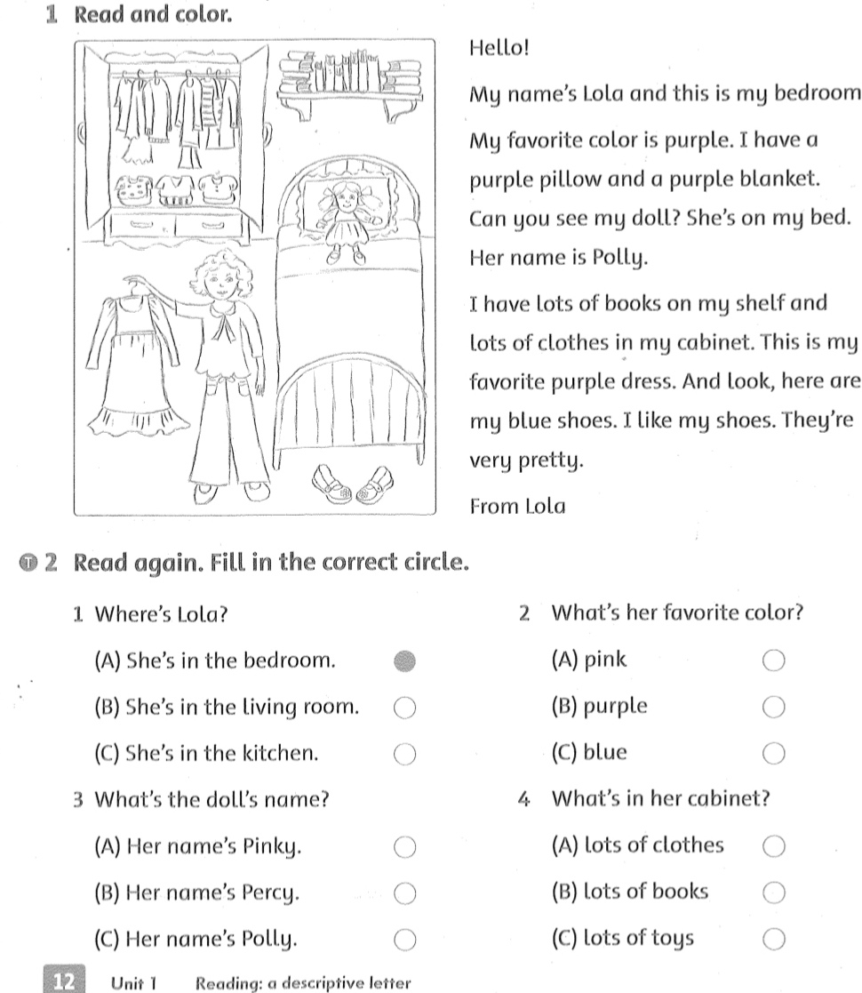

Exercise 3. Read. Underline the? and circle the .( Gạch dưới dấu chầm hỏi và khoanh tròn dấu chấm.

1. Where’s your bed ?

It’s in my bedroom .

1. What’s on your shelf ?

My book are on my shelf .

1. Do you like your bedroom ?

Yes, I do .

Exercise 4. Write the capital letters the? Or .

1. what’s her name -> What’s her name?
2. her name’s Lola ->
3. what’s on her shelf ->

Exercise 5: Circle the things in your bedroom.Write how many in the box.

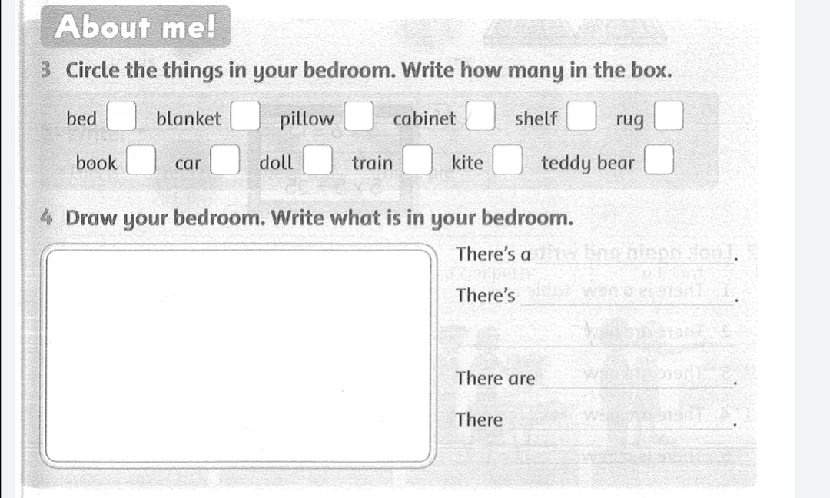

Exercise 6: Draw the things in your bedroom.Write what is in your bedroom.

